Project Name: | Roles in an Atern project fit into three categories: Project Level; Solution Development Team; and Other.  Project Level roles are responsible for overall strategy, business perspective and governance. The project is directed by the project manager. Solution Development Team roles are responsible for the detailed work involved in defining, developing, testing and deploying the solution. Other roles provide alternative viewpoints, specialist user knowledge and specific skills needed to guide the project throughout its lifecycle. Roles do not necessarily equate to individuals, except at Project Level. A team can only ever have one leader, but otherwise one person may cover multiple roles and a single role can be shared between several people.  The diagram below shows how an Atern team is structured. Role types are colour-coded to differentiate between business (orange), development (green) and project management roles (blue).

Role | Name | Appointed By | Date of Appointment
Project Level Roles
Business Sponsor
Business Visionary
Project Manager
Technical Co-ordinator
Solution Development Team Roles
Team Leader
Business Ambassador
Business Analyst
Solution Developer
Solution Tester
 | [note add additional teams/roles as required) |  | 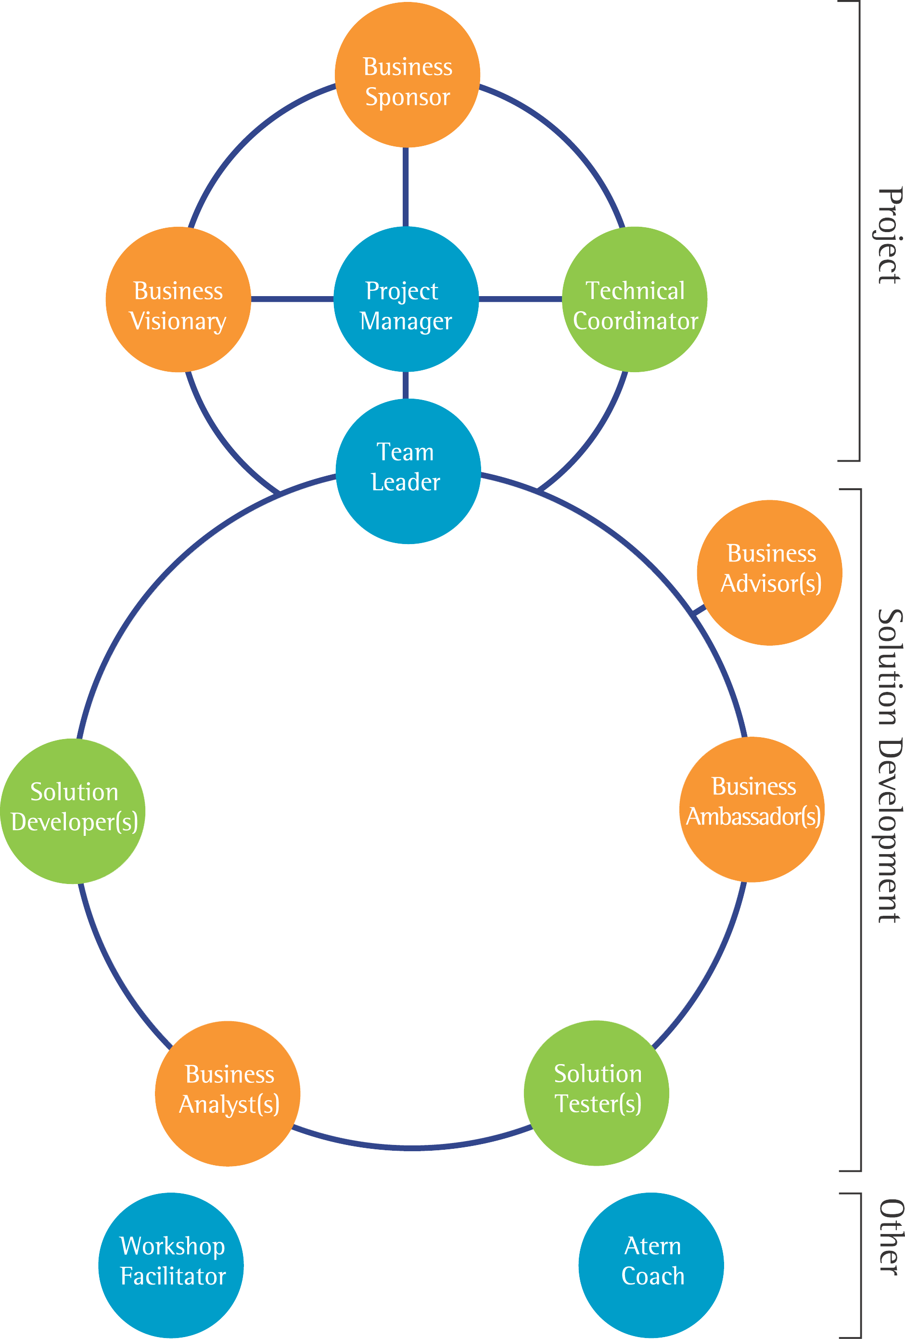
Other Roles
Workshop Facilitator
Business Advisor
Atern Coach

